1. **Reading and Writing Text Files**
   * **Problem**: Write a program to read from one text file and write its contents to another file.
   * **Example**: Given a text file input.txt, create a new file output.txt with the same content.
   * **Objective**: Read from a file, process the data if needed, and write it to a new file.

**Program code :**

with open('input.txt', 'r') as input_file:

    # Read the contents of the input file

    content = input_file.read()

# Open the output file in write mode

with open('output.txt', 'w') as output_file:

    # Write the content to the output file

    output_file.write(content)

print("Contents of 'input.txt' have been successfully copied to 'output.txt'.")

**Output :**

$ python "d:\sohamsaha\Documents\sohamsaha\B.Tech CSE\CSE SEM-3\Programing with Python and C\tempCodeRunnerFile.py"

Contents of 'input.txt' have been successfully copied to 'output.txt'.

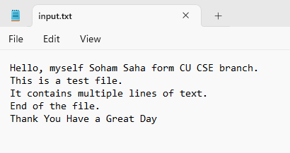 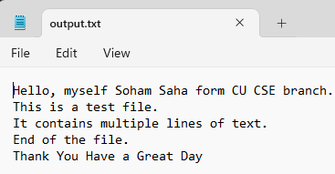

1. **Count Word Frequency in a Text File**
   * **Problem**: Write a Python program to read a text file and calculate the frequency of each word in the file.
   * **Example**: Given a text file, count how many times each word appears and display the results in descending order of frequency.
   * **Objective**: Read file contents, split the text into words, and count word frequencies using dictionaries.

**Program code :**

from collections import Counter

# Open the input file in read mode

with open(‘input.txt’, ‘r’) as file:

    # Read the contents of the file

    text = file.read()

# Split the text into words (removing punctuation and converting to lowercase)

words = text.lower().split()

# Use Counter to count the frequency of each word

word_counts = Counter(words)

# Sort the words by frequency in descending order

sorted_word_counts = sorted(word_counts.items(), key=lambda x: x[1], reverse=True)

# Display the word frequencies

print(“Word Frequencies (Descending Order):”)

for word, count in sorted_word_counts:

    print(f”{word}: {count}”)

**Output :**

$ python "d:\sohamsaha\Documents\sohamsaha\B.Tech CSE\CSE SEM-3\Programing with Python and C\assg2.py"

Word Frequencies (Descending Order):

a: 2

file.: 2

of: 2

hello,: 1

myself: 1

soham: 1

saha: 1

form: 1

cu: 1

cse: 1

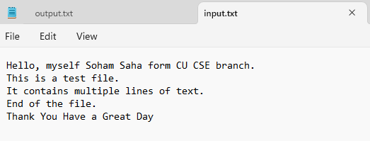branch.: 1

this: 1

is: 1

test: 1

it: 1

contains: 1

multiple: 1

lines: 1

text.: 1

end: 1

the: 1

thank: 1

you: 1

have: 1

great: 1

day: 1

1. **Merging Multiple Text Files into One**
   * **Problem**: Merge the contents of multiple text files into a single file.
   * **Example**: Given three text files (file1.txt, file2.txt, file3.txt), merge their contents into a new file merged.txt.
   * **Objective**: Open and read multiple files, then write their contents into a single file.

**Program Code :**

# List of input files to merge

input_files = ['file1.txt', 'file2.txt', 'file3.txt']

# Name of the output file

output_file = 'merged.txt'

# Open the output file in write mode

with open(output_file, 'w') as outfile:

    # Loop through each input file

    for file in input_files:

        try:

            # Open the input file in read mode

            with open(file, 'r') as infile:

                # Read and write the content to the output file

                content = infile.read()

                outfile.write(content)

                # Add a newline to separate files (optional)

                outfile.write('\n')

            print(f"Successfully merged {file}")

        except FileNotFoundError:

            print(f"File not found: {file}")

print(f"All files have been merged into {output_file}.")

**Output :**

$ python "d:\sohamsaha\Documents\sohamsaha\B.Tech CSE\CSE SEM-3\Programing with Python and C\tempCodeRunnerFile.py"

Successfully merged file1.txt

Successfully merged file2.txt

Successfully merged file3.txt

All files have been merged into merged.txt.

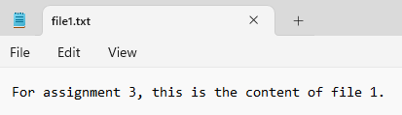 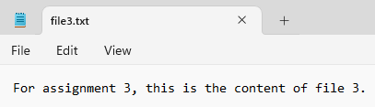

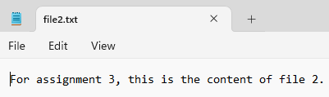 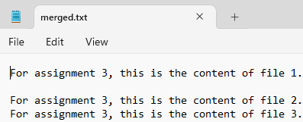

1. **File Comparison**
   * **Problem**: Write a Python program to compare two text files and highlight the differences between them.
   * **Example**: Compare file1.txt and file2.txt line by line and print the differences.
   * **Objective**: Read both files, compare their contents, and identify the differences (line by line or word by word).

**Program code** :

from difflib import Differ

# Function to compare two files line by line

def compare_files(file1, file2):

    try:

        # Open both files in read mode

        with open(file1, 'r') as f1, open(file2, 'r') as f2:

            # Read all lines from both files

            lines1 = f1.readlines()

            lines2 = f2.readlines()

        print(f"Comparing '{file1}' and '{file2}':\n")

        # Get the maximum number of lines from both files

        max_lines = max(len(lines1), len(lines2))

        # Compare files line by line

        print("Line-by-Line Comparison:\n")

        for i in range(max_lines):

            # Get lines from each file, defaulting to an empty string if the line doesn't exist

            line1 = lines1[i].strip() if i < len(lines1) else "(no line)"

            line2 = lines2[i].strip() if i < len(lines2) else "(no line)"

            # Highlight differences

            if line1 != line2:

                print(f"Line {i + 1}:")

                print(f"  File 1: {line1}")

                print(f"  File 2: {line2}")

                print()

        # Word-by-word comparison for differing lines

        print("\nWord-by-Word Comparison (for differing lines):\n")

        differ = Differ()

        for i in range(max_lines):

            line1 = lines1[i].strip() if i < len(lines1) else ""

            line2 = lines2[i].strip() if i < len(lines2) else ""

            if line1 != line2:

                print(f"Line {i + 1}:")

                diff = list(differ.compare(line1.split(), line2.split()))

                for word in diff:

                    if word.startswith('- '):

                        print(f"  Missing in File 2: {word[2:]}")

                    elif word.startswith('+ '):

                        print(f"  Missing in File 1: {word[2:]}")

                    elif word.startswith('? '):

                        pass  # Ignore alignment markers

                    else:

                        print(f"  Common: {word[2:]}")

                print()

        print("Comparison complete.")

    except FileNotFoundError as e:

        print(f"Error: {e}")

# File names to compare

file1 = 'assg4_file1.txt'

file2 = 'assg4_file2.txt'

# Compare the files

compare_files(file1, file2)

**Output :**

$ python "d:\sohamsaha\Documents\sohamsaha\B.Tech CSE\CSE SEM-3\Programing with Python and C\tempCodeRunnerFile.py"

Comparing 'assg4_file1.txt' and 'assg4_file2.txt':

Line-by-Line Comparison:

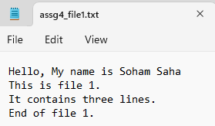

Line 2:

File 1: This is file 1.

File 2: This is file 2.

Line 4:

File 1: End of file 1.

File 2: The final line is different for this file.

Word-by-Word Comparison (for differing lines):

Line 2:

Common: This

Common: is

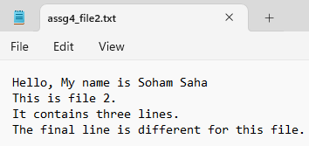 Common: file

Missing in File 2: 1.

Missing in File 1: 2.

Line 4:

Missing in File 2: End

Missing in File 2: of

Missing in File 1: The

Missing in File 1: final

Missing in File 1: line

Missing in File 1: is

Missing in File 1: different

Missing in File 1: for

Missing in File 1: this

Missing in File 2: file

Missing in File 1: file.

Missing in File 2: 1.

Comparison complete.

1. **Log File Analyzer**
   * **Problem**: Write a program to analyze a log file and extract useful information such as error counts and timestamps.
   * **Example**: Given a server log file, count the number of error occurrences and list the corresponding timestamps.
   * **Objective**: Parse and process log files to extract patterns like error messages, IP addresses, or other critical information.

**Program Code** :

import re

from collections import Counter

def analyze_log_file(log_file):

    try:

        # Open the log file in read mode

        with open(log_file, 'r') as file:

            lines = file.readlines()

        # Initialize variables

        error_count = Counter()  # To count occurrences of each error

        error_details = []  # To store timestamps and error messages

        # Regex patterns for timestamp and error messages

        timestamp_pattern = r'\[(.*?)\]'  # Matches timestamps like [2025-01-25 10:00:00]

        error_pattern = r'(ERROR|WARNING|CRITICAL): (.+)'  # Matches error messages with their severity

        # Process each line in the log file

        for line in lines:

            timestamp_match = re.search(timestamp_pattern, line)

            error_match = re.search(error_pattern, line)

            if error_match:

                # Extract timestamp and error message

                timestamp = timestamp_match.group(1) if timestamp_match else "No timestamp"

                error_message = error_match.group(2)

                severity = error_match.group(1)

                # Increment error count and store details

                error_count[error_message] += 1

                error_details.append((timestamp, severity, error_message))

        # Display results

        print("Error Counts:")

        for error, count in error_count.items():

            print(f"{error}: {count} occurrences")

        print("\nError Details:")

        for timestamp, severity, message in error_details:

            print(f"[{timestamp}] {severity}: {message}")

    except FileNotFoundError:

        print(f"Error: File '{log_file}' not found.")

# Specify the log file name

log_file = 'server.log'

# Analyze the log file

analyze_log_file(log_file)

**Output :**

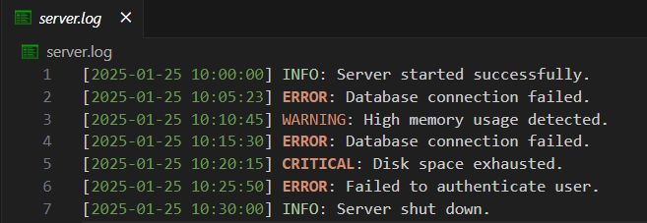$ python "d:\sohamsaha\Documents\sohamsaha\B.Tech CSE\CSE SEM-3\Programing with Python and C\tempCodeRunnerFile.py"

Error Counts:

Database connection failed.: 2 occurrences

High memory usage detected.: 1 occurrences

Disk space exhausted.: 1 occurrences

Failed to authenticate user.: 1 occurrences

Error Details:

[2025-01-25 10:05:23] ERROR: Database connection failed.

[2025-01-25 10:10:45] WARNING: High memory usage detected.

[2025-01-25 10:15:30] ERROR: Database connection failed.

[2025-01-25 10:20:15] CRITICAL: Disk space exhausted.

[2025-01-25 10:25:50] ERROR: Failed to authenticate user.

1. **CSV File Reader and Writer**
   * **Problem**: Write a program to read data from a CSV file, modify the data, and write it to another CSV file.
   * **Example**: Given a CSV file containing user information, modify one of the fields (e.g., change email addresses) and save the changes to a new CSV file.
   * **Objective**: Work with CSV files, reading and writing data using Python’s csv module.

**Program Code:**

import csv

def modify_csv(input_file, output_file, field_to_modify, modify_function):

    try:

        # Read the data from the input CSV file

        with open(input_file, 'r', newline='') as infile:

            reader = csv.DictReader(infile)

            rows = list(reader)  # Store all rows in a list

            fieldnames = reader.fieldnames  # Get field names (headers)

        # Check if the field to modify exists

        if field_to_modify not in fieldnames:

            print(f"Error: Field '{field_to_modify}' not found in the CSV file.")

            return

        # Modify the specified field using the provided function

        for row in rows:

            row[field_to_modify] = modify_function(row[field_to_modify])

        # Write the modified data to the output CSV file

        with open(output_file, 'w', newline='') as outfile:

            writer = csv.DictWriter(outfile, fieldnames=fieldnames)

            writer.writeheader()  # Write the header

            writer.writerows(rows)  # Write the modified rows

        print(f"CSV file modified successfully and saved as '{output_file}'.")

    except FileNotFoundError:

        print(f"Error: File '{input_file}' not found.")

    except Exception as e:

        print(f"An error occurred: {e}")

# Example modify function to change email addresses

def modify_email(email):

    if '@' in email:

        username, domain = email.split('@')

        return f"{username}@newdomain.com"  # Change domain

    return email

# File paths

input_file = 'users.csv'  # Input CSV file

output_file = 'updated_users.csv'  # Output CSV file

# Field to modify

field_to_modify = 'Email'

# Modify the CSV file

modify_csv(input_file, output_file, field_to_modify, modify_email)

**Output :**

user.csv updated_user.csv

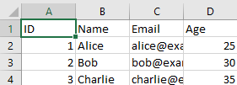 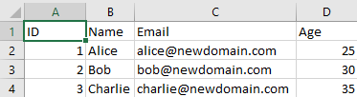

$ python "d:\sohamsaha\Documents\sohamsaha\B.Tech CSE\CSE SEM-3\Programing with Python and C\assg6.py"

CSV file modified successfully and saved as 'updated_users.csv'.

1. **Parsing JSON Files**
   * **Problem**: Write a program to read a JSON file, parse the data, and print it in a human-readable format.
   * **Example**: Given a JSON file with nested structures, extract specific pieces of data (e.g., user details) and display them.
   * **Objective**: Read and parse JSON files using Python’s json module and extract specific data fields.

Program Code :

import json

def parse_json_file(json_file, fields_to_extract=None):

    try:

        # Open and read the JSON file

        with open(json_file, 'r') as file:

            data = json.load(file)  # Parse JSON into a Python dictionary or list

        # Print the JSON data in a human-readable format

        print("Full JSON Data (Formatted):")

        print(json.dumps(data, indent=4))  # Pretty print JSON

        # Extract and print specific fields if requested

        if fields_to_extract:

            print("\nExtracted Data:")

            for field in fields_to_extract:

                extracted_value = extract_field(data, field)

                print(f"{field}: {extracted_value if extracted_value else 'Field not found'}")

        else:

            print("\nNo specific fields to extract.")

    except FileNotFoundError:

        print(f"Error: File '{json_file}' not found.")

    except json.JSONDecodeError:

        print("Error: Invalid JSON format.")

    except Exception as e:

        print(f"An error occurred: {e}")

def extract_field(data, field):

    # Recursively extract data from nested JSON structures

    keys = field.split('.')  # Support nested fields with dot notation

    value = data

    for key in keys:

        if isinstance(value, dict) and key in value:

            value = value[key]

        else:

            return None  # Field not found

    return value

# File path

json_file = 'data.json'

# Fields to extract (supports dot notation for nested fields)

fields_to_extract = ['user.name', 'user.email', 'user.details.age']

# Parse and process the JSON file

parse_json_file(json_file, fields_to_extract)

Output :

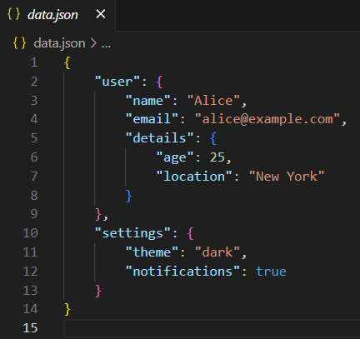$ python "d:\sohamsaha\Documents\sohamsaha\B.Tech CSE\CSE SEM-3\Programing with Python and C\assg7.py"

Full JSON Data (Formatted):

{

"user": {

"name": "Alice",

"email": "alice@example.com",

"details": {

"age": 25,

"location": "New York"

}

},

"settings": {

"theme": "dark",

"notifications": true

}

}

Extracted Data:

user.name: Alice

user.email: alice@example.com

user.details.age: 25

1. **Binary File Reader and Writer**
   * **Problem**: Write a program to read binary data from a file, manipulate it, and write the modified data back to a new file.
   * **Example**: Read a binary image file, modify some of the pixel values, and save it as a new image.
   * **Objective**: Work with binary files using Python’s file I/O methods like rb and wb modes.
2. **File Encryption and Decryption**
   * **Problem**: Implement a program that encrypts the content of a text file and decrypts it back to its original form.
   * **Example**: Given a text file, use a simple encryption algorithm (like Caesar Cipher or XOR) to encrypt the file content and then decrypt it.
   * **Objective**: Read from a file, encrypt the data, write it to a new file, and implement the reverse process to decrypt.
3. **File Compression and Decompression**
   * **Problem**: Write a program to compress a file using gzip or zip and decompress it back to its original form.
   * **Example**: Compress a text file data.txt into data.zip and then decompress it.
   * **Objective**: Work with file compression and decompression using Python’s gzip or zipfile module.
4. **Counting Lines, Words, and Characters in a File**
   * **Problem**: Write a program to count the number of lines, words, and characters in a text file.
   * **Example**: Given a text file, calculate the number of lines, words, and characters, and print the results.
   * **Objective**: Read the file and perform basic text analysis to count lines, words, and characters.

**Program Code :**

def count_file_content(file_path):

    try:

        # Open the file in read mode

        with open(file_path, 'r') as file:

            lines = file.readlines()  # Read all lines

            lines = [line for line in lines if line.strip()] # Remove empty lines

        # Count the number of lines

        line_count = len(lines)

        # Count the number of words and characters

        word_count = 0

        char_count = 0

        for line in lines:

            words = line.split()  # Split the line into words

            word_count += len(words)  # Add word count of this line

            char_count += len(line)  # Add character count of this line

        # Print the results

        print(f"File: {file_path}")

        print(f"Number of lines: {line_count}")

        print(f"Number of words: {word_count}")

        print(f"Number of characters: {char_count}")

    except FileNotFoundError:

        print(f"Error: File '{file_path}' not found.")

    except Exception as e:

        print(f"An error occurred: {e}")

# File path

file_path = 'example.txt'  # Replace with your text file's path

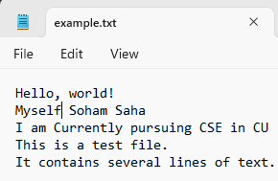# Count lines, words, and characters in the file

count_file_content(file_path)

**Output :**

$ python "d:\sohamsaha\Documents\sohamsaha\B.Tech CSE\CSE SEM-3\Programing with Python and C\tempCodeRunnerFile.py"

File: example.txt

Number of lines: 5

Number of words: 23

Number of characters: 122

1. **Finding Duplicate Files in a Directory**
   * **Problem**: Write a program to scan a directory and identify duplicate files based on file content (not file names).
   * **Example**: Compare all files in a given directory and identify any files that have the same content.
   * **Objective**: Use hashing or byte-by-byte comparison to identify duplicate files in a directory.

**Program Code :**   
import os

import hashlib

def hash_file(file_path):

    """Generate a hash for the file content using SHA-256."""

    hash_obj = hashlib.sha256()

    try:

        with open(file_path, 'rb') as file:

            while chunk := file.read(4096):  # Read the file in chunks to handle large files

                hash_obj.update(chunk)

        return hash_obj.hexdigest()

    except Exception as e:

        print(f"Error hashing file {file_path}: {e}")

        return None

def find_duplicate_files(directory):

    """Find duplicate files in the given directory based on content."""

    file_hashes = {}  # Dictionary to store hash: file paths

    duplicates = []  # List to store duplicate file pairs

    # Walk through the directory and its subdirectories

    for root, _, files in os.walk(directory):

        for file in files:

            file_path = os.path.join(root, file)

            file_hash = hash_file(file_path)

            if file_hash:

                if file_hash in file_hashes:

                    duplicates.append((file_hashes[file_hash], file_path))

                else:

                    file_hashes[file_hash] = file_path

    return duplicates

def display_duplicates(duplicates):

    """Display duplicate file information."""

    if duplicates:

        print("Duplicate files found:")

        for original, duplicate in duplicates:

            print(f"Original: {original}")

            print(f"Duplicate: {duplicate}\n")

    else:

        print("No duplicate files found.")

# Directory to scan

directory = input("Enter the directory to scan for duplicates: ")

# Find and display duplicate files

duplicates = find_duplicate_files(directory)

display_duplicates(duplicates)

**Output :**

$ python "d:\sohamsaha\Documents\sohamsaha\B.Tech CSE\CSE SEM-3\Programing with Python and C\assg12.py"

Enter the directory to scan for duplicates: D:\sohamsaha\Documents\sohamsaha\B.Tech CSE\CSE SEM-3\Programing with Python and C\example_dir

Duplicate files found:

Original: D:\sohamsaha\Documents\sohamsaha\B.Tech CSE\CSE SEM-3\Programing with Python and C\example_dir\old_duplicate_of_file1.txt

Duplicate: D:\sohamsaha\Documents\sohamsaha\B.Tech CSE\CSE SEM-3\Programing with Python and C\example_dir\old_file1.txt

Original: D:\sohamsaha\Documents\sohamsaha\B.Tech CSE\CSE SEM-3\Programing with Python and C\example_dir\old_file2.txt

Duplicate: D:\sohamsaha\Documents\sohamsaha\B.Tech CSE\CSE SEM-3\Programing with Python and C\example_dir\sub_dir\2nd_duplicate.txt

1. **Directory Walker (Recursive File Listing)**
   * **Problem**: Write a Python program to recursively list all files and directories in a given directory.
   * **Example**: Given a directory, output a tree-like structure of all files and subdirectories within it.
   * **Objective**: Use os or os.path to traverse directories and print their structure.

Program Code :

import os

def list_directory(directory, indent=0):

    """Recursively list all files and directories in a given directory."""

    try:

        # Get all items in the directory

        items = os.listdir(directory)

    except PermissionError:

        print(" " * indent + f"[Permission Denied]: {directory}")

        return

    except FileNotFoundError:

        print(f"Error: Directory '{directory}' not found.")

        return

    # Sort items to display directories first

    items.sort(key=lambda x: (not os.path.isdir(os.path.join(directory, x)), x.lower()))

    for item in items:

        item_path = os.path.join(directory, item)

        # Print the item with indentation

        if os.path.isdir(item_path):

            print(" " * indent + f"[DIR] {item}")

            # Recursively list subdirectories

            list_directory(item_path, indent + 4)

        else:

            print(" " * indent + f"[FILE] {item}")

# Get the directory path from the user

directory = input("Enter the directory to list: ")

# Start listing

print(f"Listing files and directories in: {directory}")

list_directory(directory)

**Output :**

$ python "d:\sohamsaha\Documents\sohamsaha\B.Tech CSE\CSE SEM-3\Programing with Python and C\assg13.py"

Enter the directory to list: D:\sohamsaha\Documents\sohamsaha\B.Tech CSE\CSE SEM-3\Programing with Python and C\example_dir

Listing files and directories in: D:\sohamsaha\Documents\sohamsaha\B.Tech CSE\CSE SEM-3\Programing with Python and C\example_dir

[DIR] sub_dir

[FILE] 2nd_duplicate.txt

[FILE] old_duplicate_of_file1.txt

[FILE] old_file1.txt

[FILE] old_file2.txt

1. **Renaming Files in a Directory**
   * **Problem**: Write a program to rename all files in a directory according to a specific pattern.
   * **Example**: Rename all .txt files in a directory by adding a prefix like old_ to their names.
   * **Objective**: Use Python’s os or os.rename() function to batch rename files based on specific criteria.

**Program Code** :

import os

def rename_files_in_directory(directory, prefix='', suffix='', extension_filter=None):

    try:

        # Get a list of all files in the directory

        files = os.listdir(directory)

        for file in files:

            file_path = os.path.join(directory, file)

            # Skip directories

            if not os.path.isfile(file_path):

                continue

            # Filter by file extension if specified

            if extension_filter and not file.endswith(extension_filter):

                continue

            # Extract file name and extension

            file_name, file_ext = os.path.splitext(file)

            # Construct the new file name

            new_file_name = f"{prefix}{file_name}{suffix}{file_ext}"

            new_file_path = os.path.join(directory, new_file_name)

            # Rename the file

            os.rename(file_path, new_file_path)

            print(f"Renamed: {file} -> {new_file_name}")

        print("\nRenaming complete!")

    except FileNotFoundError:

        print(f"Error: Directory '{directory}' not found.")

    except Exception as e:

        print(f"An error occurred: {e}")

# Get user inputs

directory = input("Enter the directory path: ")

prefix = input("Enter a prefix to add (leave blank if not needed): ")

suffix = input("Enter a suffix to add (leave blank if not needed): ")

extension_filter = input("Enter the file extension to filter by (e.g., .txt, leave blank for all files): ")

# Rename files in the directory

rename_files_in_directory(directory, prefix, suffix, extension_filter)

**Output :**

$ python "d:\sohamsaha\Documents\sohamsaha\B.Tech CSE\CSE SEM-3\Programing with Python and C\assg14.py"

Enter the directory path: D:\sohamsaha\Documents\sohamsaha\B.Tech CSE\CSE SEM-3\Programing with Python and C\example_dir

Enter a prefix to add (leave blank if not needed): New_

Enter a suffix to add (leave blank if not needed):

Enter the file extension to filter by (e.g., .txt, leave blank for all files):

Renamed: old_duplicate_of_file1.txt -> New_old_duplicate_of_file1.txt

Renamed: old_file1.txt -> New_old_file1.txt

Renamed: old_file2.txt -> New_old_file2.txt

Renaming complete!

1. **File Metadata Extraction**
   * **Problem**: Write a program to extract and display metadata (such as file size, creation date, and modification date) of files in a directory.
   * **Example**: Given a directory of files, print each file’s size, creation date, and last modification date.
   * **Objective**: Use Python’s os or os.stat() methods to retrieve and display file metadata.

**Program Code :**

import os

import time

def get_file_metadata(directory):

    try:

        # Check if the directory exists

        if not os.path.isdir(directory):

            print("Error: The specified directory does not exist.")

            return

        print(f"\nMetadata for files in directory: {directory}\n")

        print(f"{'File Name':<30} {'Size (Bytes)':<15} {'Creation Date':<25} {'Modification Date':<25}")

        print("-" * 100)

        # Iterate over files in the directory

        for file_name in os.listdir(directory):

            file_path = os.path.join(directory, file_name)

            # Skip subdirectories

            if os.path.isfile(file_path):

                # Get file metadata

                file_stat = os.stat(file_path)

                file_size = file_stat.st_size

                creation_time = time.strftime('%Y-%m-%d %H:%M:%S', time.localtime(file_stat.st_ctime))

                modification_time = time.strftime('%Y-%m-%d %H:%M:%S', time.localtime(file_stat.st_mtime))

                # Print metadata

                print(f"{file_name:<30} {file_size:<15} {creation_time:<25} {modification_time:<25}")

    except Exception as e:

        print(f"An error occurred: {e}")

def main():

    # Input directory path

    directory = input("Enter the directory path: ")

    get_file_metadata(directory)

if __name__ == "__main__":

    main()

**Output :**

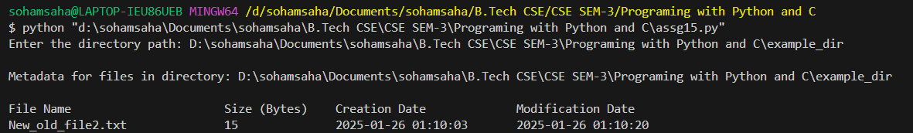

1. **Log File Rotation**
   * **Problem**: Implement a program that simulates **log file rotation** by renaming old log files and creating a new log file when the current one reaches a certain size.
   * **Example**: When the current log file exceeds 1MB, rename it and start a new log file.
   * **Objective**: Work with file sizes, renaming, and writing to new files to implement file rotation behavior.
2. **Finding and Replacing Text in Files**
   * **Problem**: Write a program that reads a file, searches for a specific text pattern, and replaces it with another text.
   * **Example**: Search for the word “error” in a log file and replace it with “warning.”
   * **Objective**: Use Python’s file reading and writing capabilities to perform search-and-replace operations in text files.

**Program code** :

def find_and_replace(file_path, search_text, replace_text, output_file=None):

    try:

        # Open and read the original file

        with open(file_path, 'r') as file:

            content = file.read()

        # Perform the search and replace operation

        modified_content = content.replace(search_text, replace_text)

        # Determine the file to save the changes

        save_path = output_file if output_file else file_path

        # Write the modified content to the output file

        with open(save_path, 'w') as file:

            file.write(modified_content)

        print(f"'{search_text}' has been replaced with '{replace_text}' in '{save_path}'.")

    except FileNotFoundError:

        print(f"Error: File '{file_path}' not found.")

    except Exception as e:

        print(f"An error occurred: {e}")

# User inputs

file_path = input("Enter the path of the file to modify: ")

search_text = input("Enter the text to search for: ")

replace_text = input("Enter the text to replace it with: ")

output_file = input("Enter the output file path (leave blank to overwrite the original file): ")

# Call the function

find_and_replace(file_path, search_text, replace_text, output_file if output_file.strip() else None)

**Output :**

$ python "d:\sohamsaha\Documents\sohamsaha\B.Tech CSE\CSE SEM-3\Programing with Python and C\tempCodeRunnerFile.py"

Enter the path of the file to modify: D:\sohamsaha\Documents\sohamsaha\B.Tech CSE\CSE SEM-3\Programing with Python and C\example_dir

Enter the text to search for: The

Enter the text to replace it with: the

Enter the output file path (leave blank to overwrite the original file):

An error occurred: [Errno 13] Permission denied: 'D:\\sohamsaha\\Documents\\sohamsaha\\B.Tech CSE\\CSE SEM-3\\Programing with Python and C\\example_dir'

1. **Generating and Writing Large Data Files**
   * **Problem**: Write a program to generate large data files, such as files containing random numbers, text, or CSV data.
   * **Example**: Generate a file with 10 million random integers and write it to a file.
   * **Objective**: Use Python to generate large datasets and write them efficiently to disk.

**Program code** :

def generate_large_data_file(filename, rows, data_type="numbers", delimiter=","):

    try:

        with open(filename, "w", newline="") as file:

            if data_type == "numbers":

                for _ in range(rows):

                    number = random.randint(1, 10**6)

                    file.write(f"{number}\n")

            elif data_type == "text":

                words = ["apple", "banana", "cherry", "date", "elderberry"]

                for _ in range(rows):

                    sentence = " ".join(random.choices(words, k=10))

                    file.write(f"{sentence}\n")

            elif data_type == "csv":

                writer = csv.writer(file, delimiter=delimiter)

                headers = ["ID", "Name", "Score"]

                writer.writerow(headers)

                for i in range(1, rows + 1):

                    row = [i, f"Name_{i}", random.randint(0, 100)]

                    writer.writerow(row)

            else:

                print("Invalid data type. Please choose 'numbers', 'text', or 'csv'.")

                return

        print(f"File '{filename}' with {rows} rows of {data_type} data created successfully.")

    except Exception as e:

        print(f"An error occurred: {e}")

# User inputs

filename = input("Enter the output file name (e.g., data.txt or data.csv): ")

rows = int(input("Enter the number of rows to generate: "))

data_type = input("Enter the type of data to generate ('numbers', 'text', 'csv'): ").lower()

delimiter = input("Enter a delimiter for CSV files (default is ','): ") or ","

# Generate the file

generate_large_data_file(filename, rows, data_type, delimiter)

1. **Checksum Calculation for Files**
   * **Problem**: Write a program to calculate a file's checksum (e.g., MD5 or SHA256) to ensure its integrity.
   * **Example**: Compute the MD5 hash of a file and verify its integrity by comparing it to a known hash.
   * **Objective**: Use Python’s hashlib module to compute and verify file checksums.

**Program code** :

**Output :**

1. **File Permissions Checker**
   * **Problem**: Write a Python program that checks the permissions of files in a directory and identifies files with insecure permissions.
   * **Example**: Scan a directory and identify files that are world-writable or have other risky permissions.
   * **Objective**: Use Python’s os and stat modules to check file permissions and highlight any potential security risks.

**Program code** :

import os

import stat

def check_file_permissions(directory):

    try:

        print(f"Scanning directory: {directory}\n")

        print(f"{'File Name':<40} {'Permissions':<15} {'Insecure?':<10}")

        print("-" * 65)

        # Walk through files in the directory

        for root, _, files in os.walk(directory):

            for file in files:

                file_path = os.path.join(root, file)

                # Get file permissions

                file_stat = os.stat(file_path)

                permissions = stat.filemode(file_stat.st_mode)

                # Check for insecure permissions (world-writable)

                is_insecure = False

                if (file_stat.st_mode & stat.S_IWOTH) != 0:  # World-writable

                    is_insecure = True

                # Check for other risky permissions

                insecure_label = "Yes" if is_insecure else "No"

                print(f"{file:<40} {permissions:<15} {insecure_label:<10}")

        print("\nScan complete.")

    except FileNotFoundError:

        print(f"Error: Directory '{directory}' not found.")

    except PermissionError:

        print("Error: Permission denied while accessing files.")

    except Exception as e:

        print(f"An error occurred: {e}")

# Get user input for the directory to scan

directory = input("Enter the directory to scan for file permissions: ")

# Perform the file permissions check

check_file_permissions(directory)

**Output :**

$ python "d:\sohamsaha\Documents\sohamsaha\B.Tech CSE\CSE SEM-3\Programing with Python and C\tempCodeRunnerFile.py"

Enter the directory to scan for file permissions: D:\sohamsaha\Documents\sohamsaha\B.Tech CSE\CSE SEM-3\Programing with Python and C\example_dir

Scanning directory: D:\sohamsaha\Documents\sohamsaha\B.Tech CSE\CSE SEM-3\Programing with Python and C\example_dir

File Name Permissions Insecure?

--------------------------------------------------------------------------------

New_old_duplicate_of_file1.txt -rw-rw-rw- Yes

New_old_file1.txt -rw-rw-rw- Yes

New_old_file2.txt -rw-rw-rw- Yes

2nd_duplicate.txt -rw-rw-rw- Yes

Scan complete.